**Project2 A Pipe-Based Word Count Tool Report**

**gzl0034 Gaoxiang Li**

**1.Separate Compilation Design(Small file only)**

Divide the project into three parts.

**(1)**word_count function: a function only use to count the words from a string(not a file)

**(2)**load_file function: a function to load the file and check error of the file type and read from the file then write to a string(buffer)

**(3)**pwordcount (main function)

A.check error of input and use load_file function to write into buffer

B.create 2 pipes

C.create parent and child process

D.send message to child process from parent process and wait child process to finish

D.read message and do word_count function send the result of word_count to parent process in child process

F.parent process return the result

**2.Implement detail**

(1)load_file function

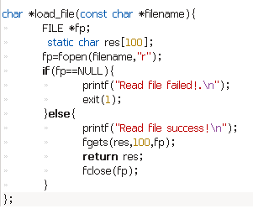

Input parameter: file name as const char

Open the file and return the txt in file as a char

1. word_count function

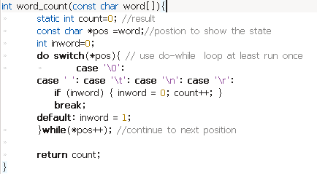

1. pwordcount (main function)

Detail in source code pwordcount.c

**3.Sample Input and Output**

(1) input: ./pwordcount

Output: 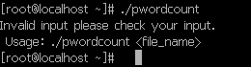

1. input: ./pwordcount test1 test2

Output: 1518037467(1)

1. Input: ./pwordcount test

Output :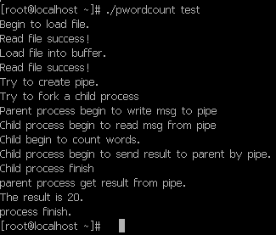

1. Input: ./pwordcount wordtest

Output: 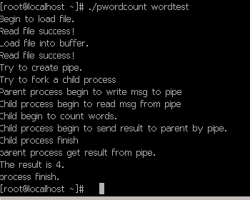

**Reference**：word_count function in stackoverflow(use the idea only)